第2次作业

危国锐 120034910021

（上海交通大学海洋学院，上海 200030）

摘要：EOF分析的结果高度依赖于区域选取. 全球EOF的结果不是各区域分别EOF的结果的简单叠加. 在全球EOF中，局部重要的气候模态可能被“淹没”在众多模态中，而不能被EOF很好地分辨出. 本文使用的程序和文档发布于<https://grwei.github.io/SJTU_2021-2022-2_MS8401/>.

关键词：词1，词2

Homework 2

Guorui Wei 120034910021

(*School of Oceanography*, *Shanghai Jiao Tong University*, *Shanghai* 200030, *China*)

**Abstract****:** The programs and documents used in this article are published at <https://grwei.github.io/SJTU_2021-2022-2_MS8401/>.

**Keywords:** keyword 1, keyword 2

**目 录**

摘要 i

Abstract i

1 Introduction 1

2 Data and Methods 1

3 Results 2

3.1 Global 2

3.2 The Pacific Ocean 4

3.3 The North Pacific Ocean 6

3.4 The Atlantic Ocean 7

3.5 The North Atlantic Ocean 9

4 Discussion 11

5 Conclusions 11

References 12

附录A 本文使用的MATLAB程序源代码 13

A.1 主程序 13

A.2 子程序 20

# Introduction

Empirical orthogonal function (EOF)[1][2]

El Niño Southern Oscillation (ENSO)[3]

The Pacific Decadal Oscillation (PDO)[4]

The Atlantic Multi-decadal Oscillation (AMO)[5]

The North Atlantic Oscillation (NAO)[6]

# Data and Methods

使用[NOAA Extended Reconstructed Sea Surface Temperature (SST) V5](https://psl.noaa.gov/data/gridded/data.noaa.ersst.v5.html)的*Monthly Mean*数据[7]，选择时间范围Jan 1900至Dec 2020.

对原始SST数据，依次作以下处理：

1. 规定数据点是等时间间隔的；
2. 逐空间点，去除该点处的SST时间序列的线性趋势，通过调用Climate Data Tools for Matlab (CDT) [1] 的detrend3函数[8]；
3. 逐空间点，去除该点处的SST时间序列的seasonal (aka. annual) cycle，通过调用CDT的deseason函数[9].

然后，分别在5个区域作EOF分析，通过调用CDT的eof函数[10]：（1）全球；（2）太平洋，范围~；（3）北太平洋，范围~；（4）大西洋，范围~；（5）北大西洋，范围~.

# Results

## Global

全球范围EOF. 第一模式，体现ENSO，年际的，解释方差>11%. 第二模式，体现PDO？~期的？第三模式，体现AMO？

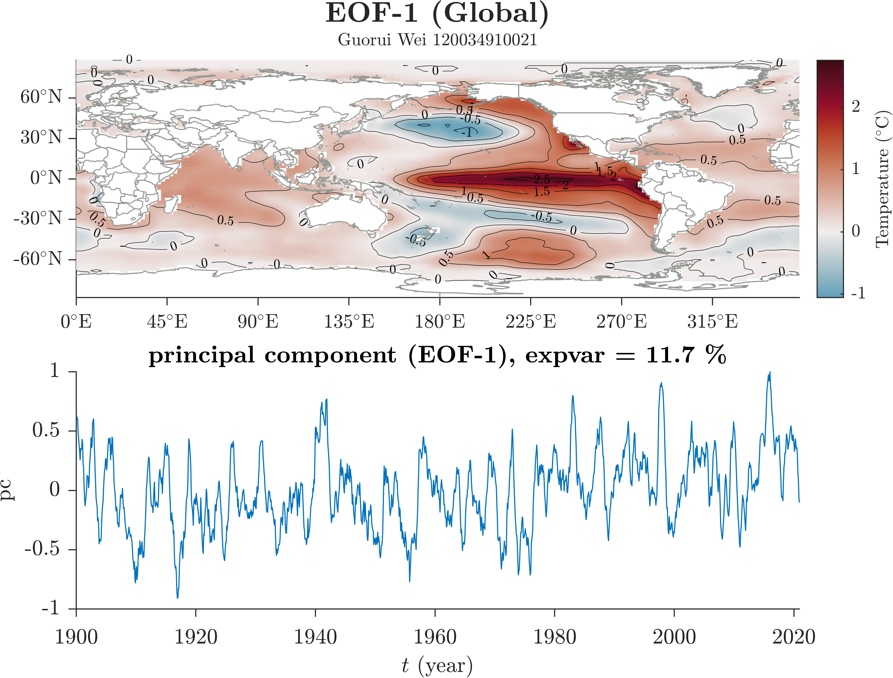

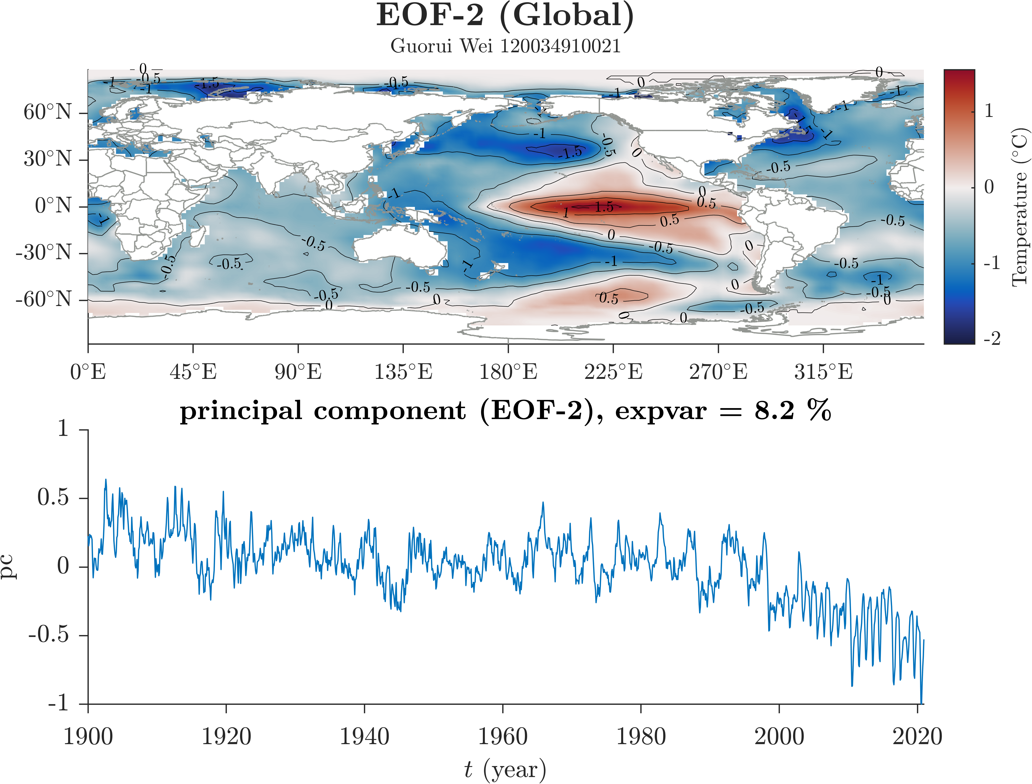

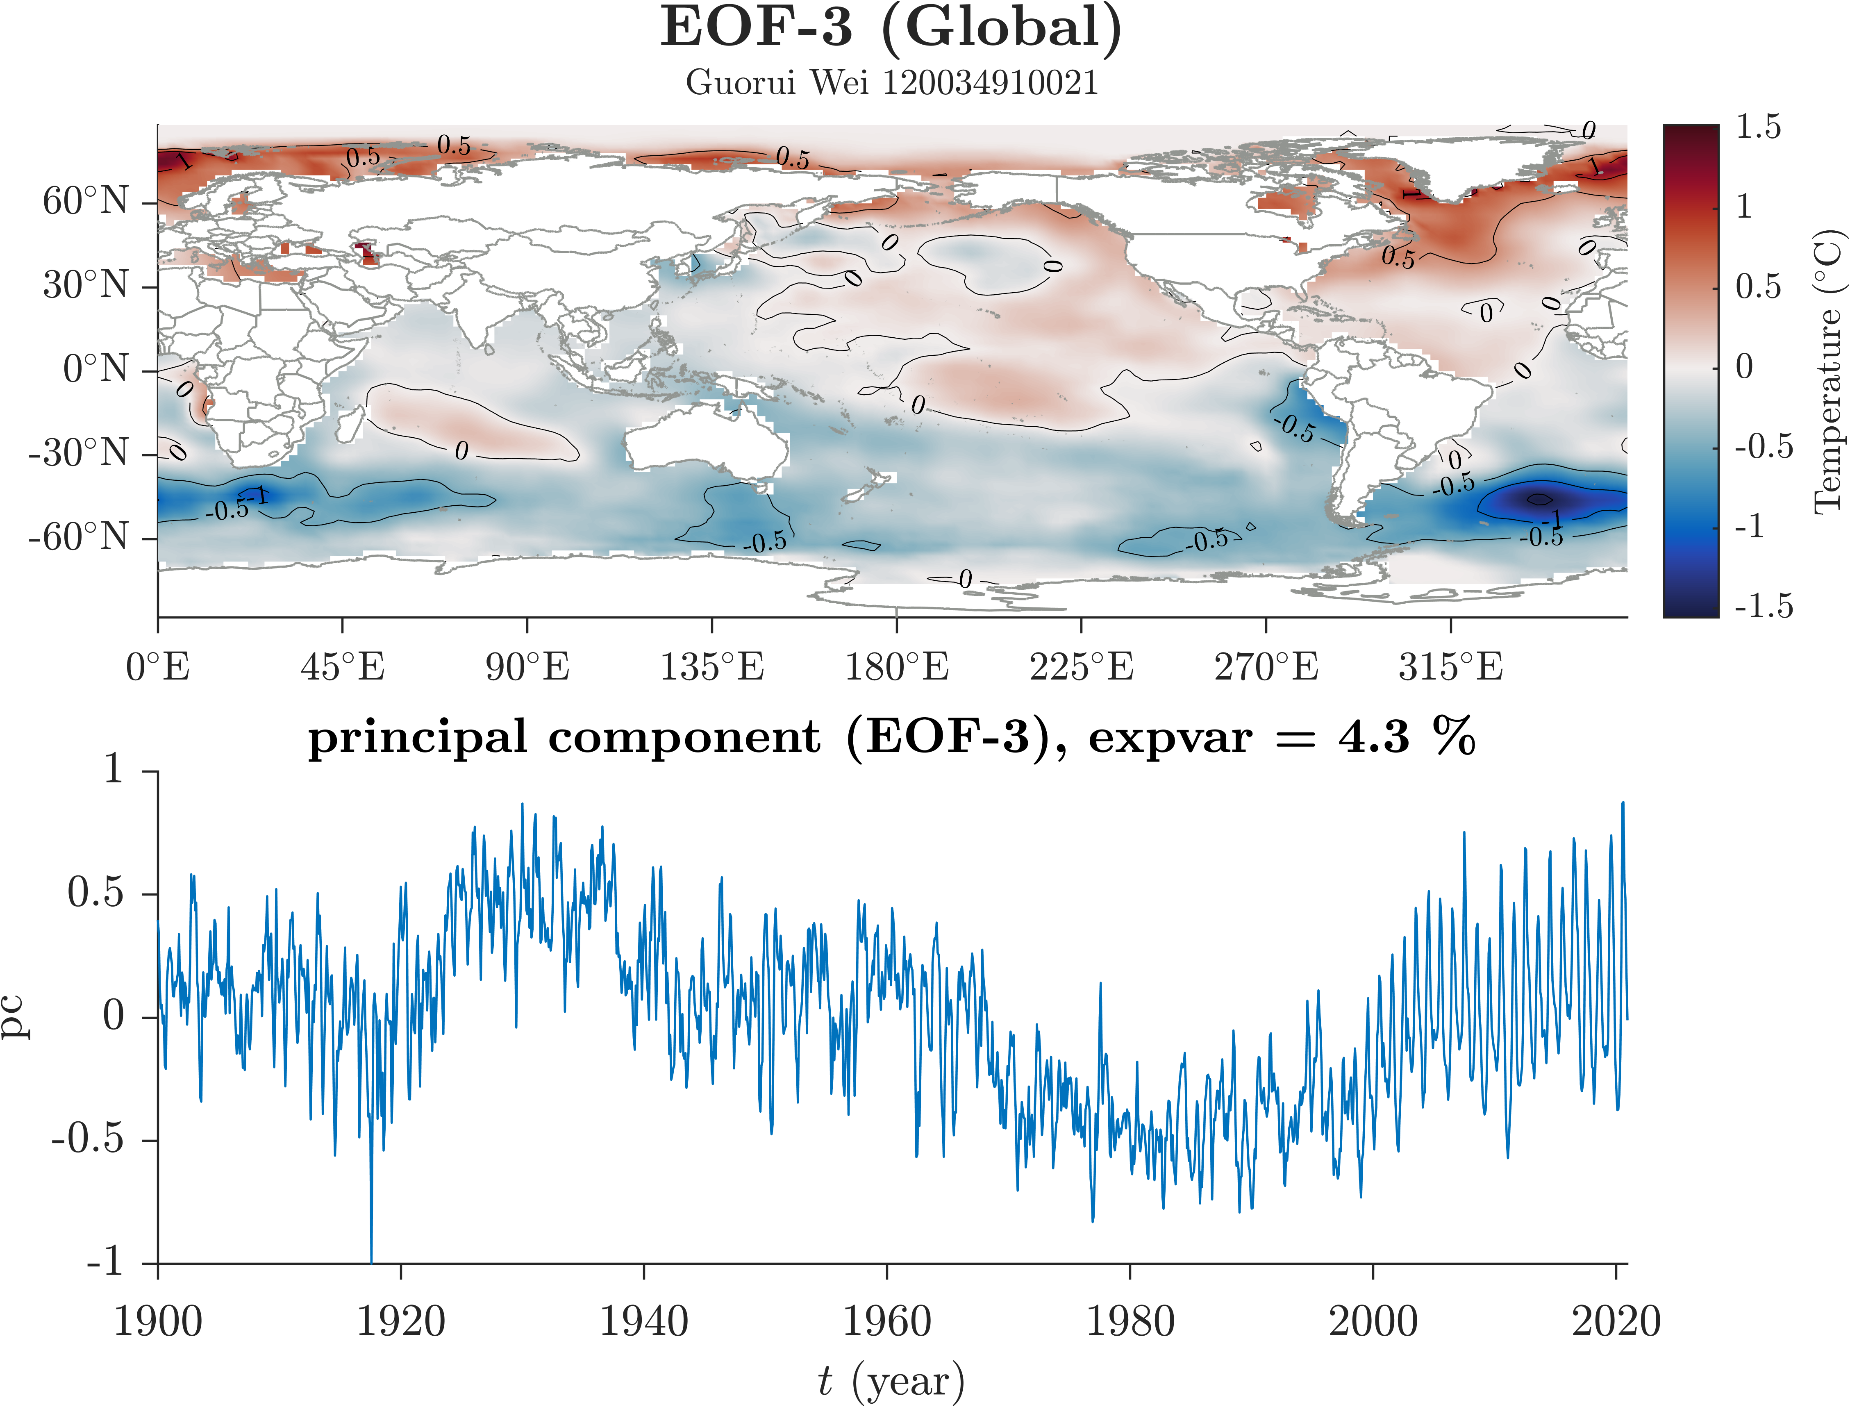

**Figure 1** 全球EOF的前3个mode，相应的principal component time series和percent of variance explained by each mode. (a) EOF-1, (b) EOF-2, (c) EOF-3.

## The Pacific Ocean

太平洋区域EOF. 第一模态，体现ENSO，解释方差>20%，年际的. 第二模态，体现PDO？~期的？第三模态？

太平洋区域EOF.，第一、二模态的空间pattern和全球区域EOF类似，且解释方差更高；第三模态在全球区域EOF中不明显.

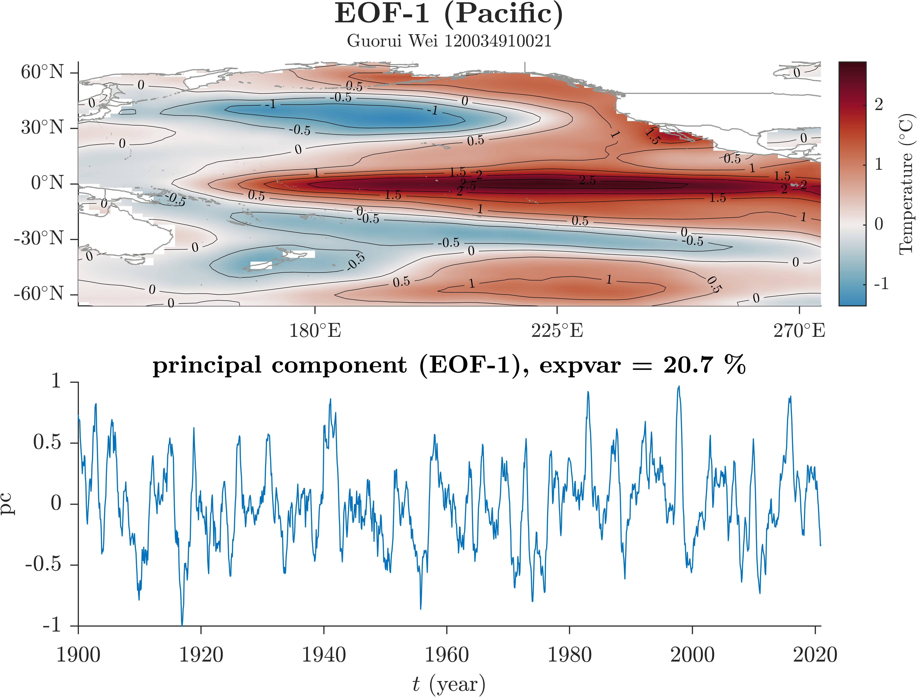

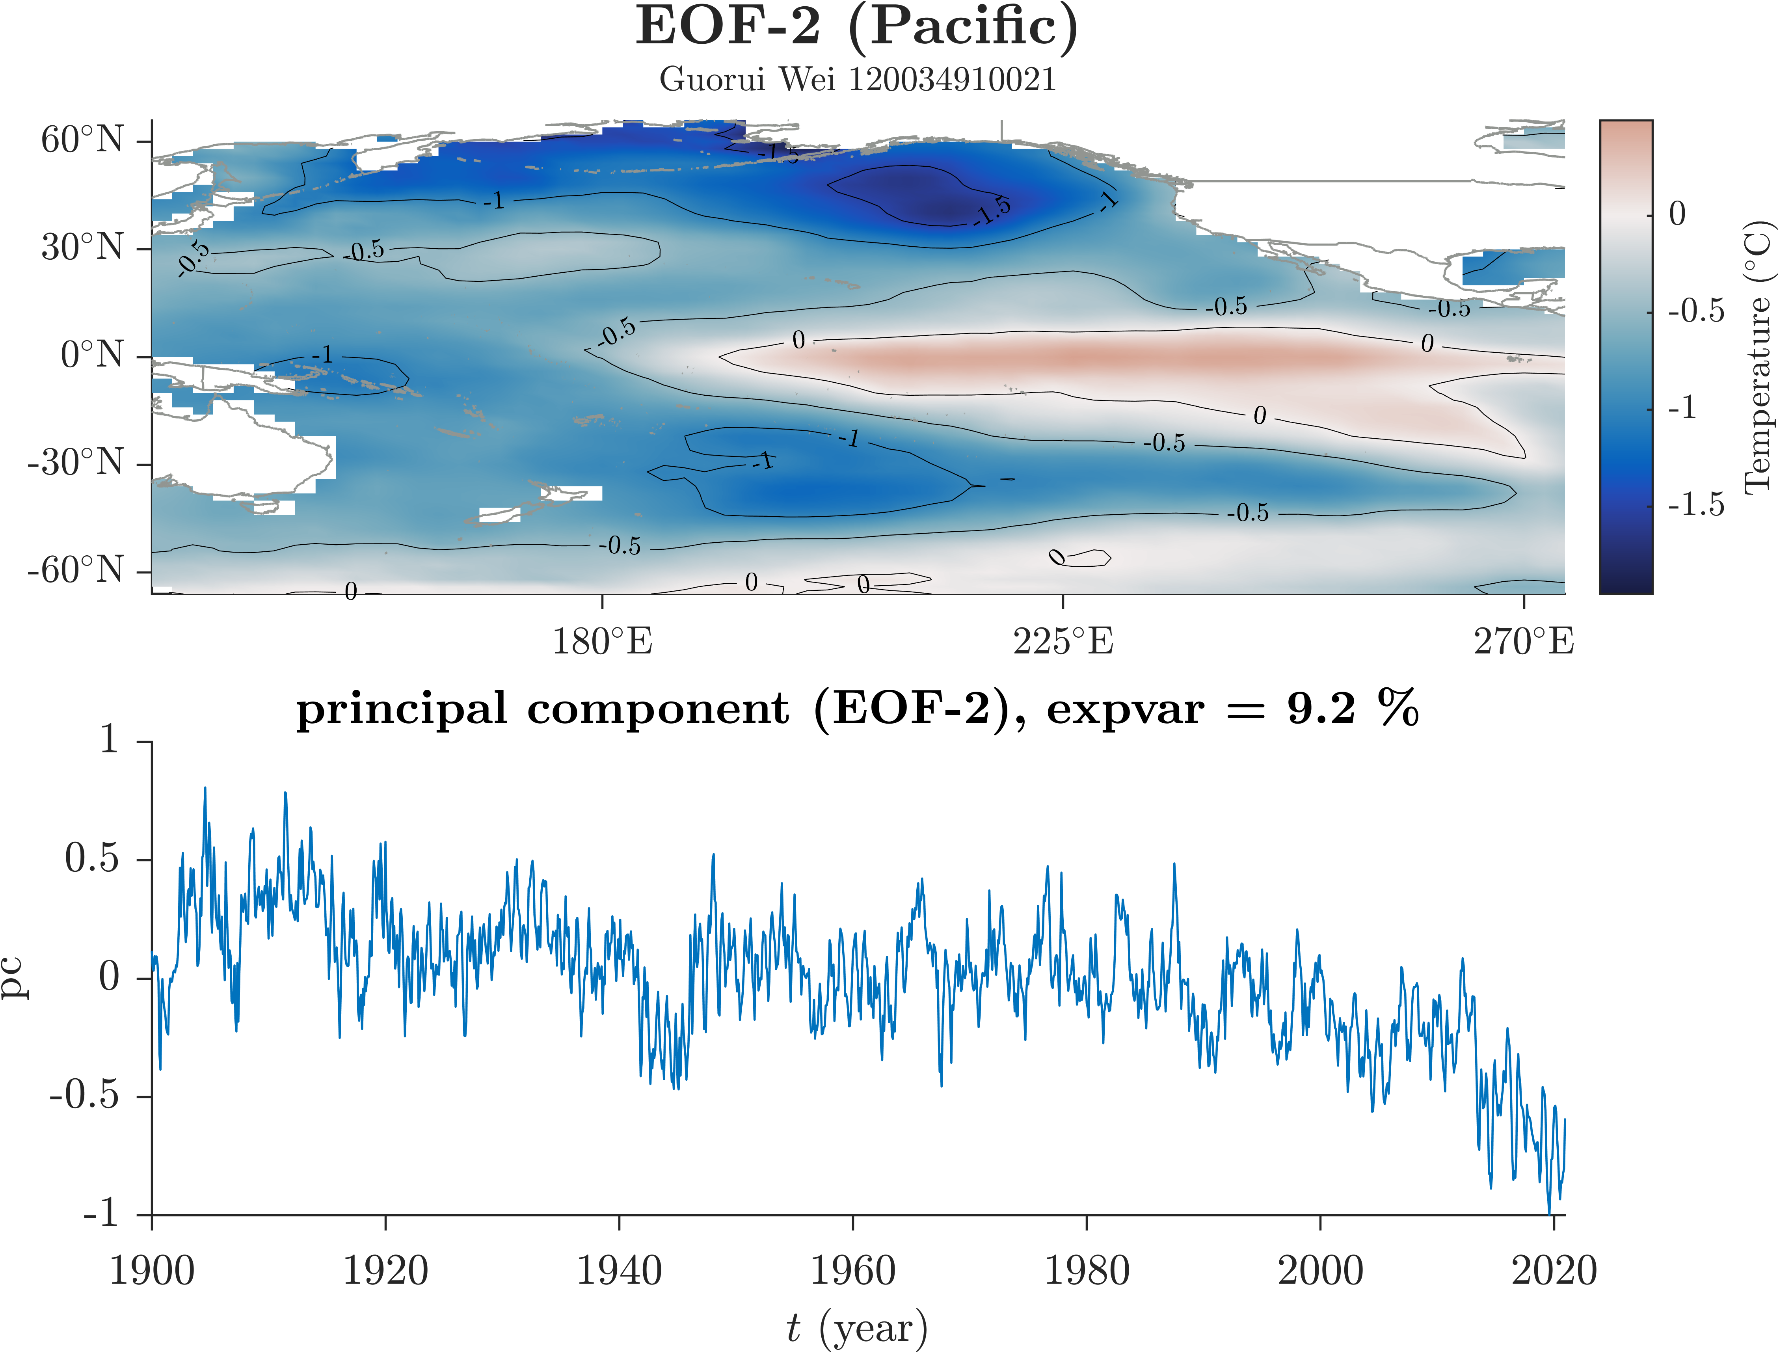

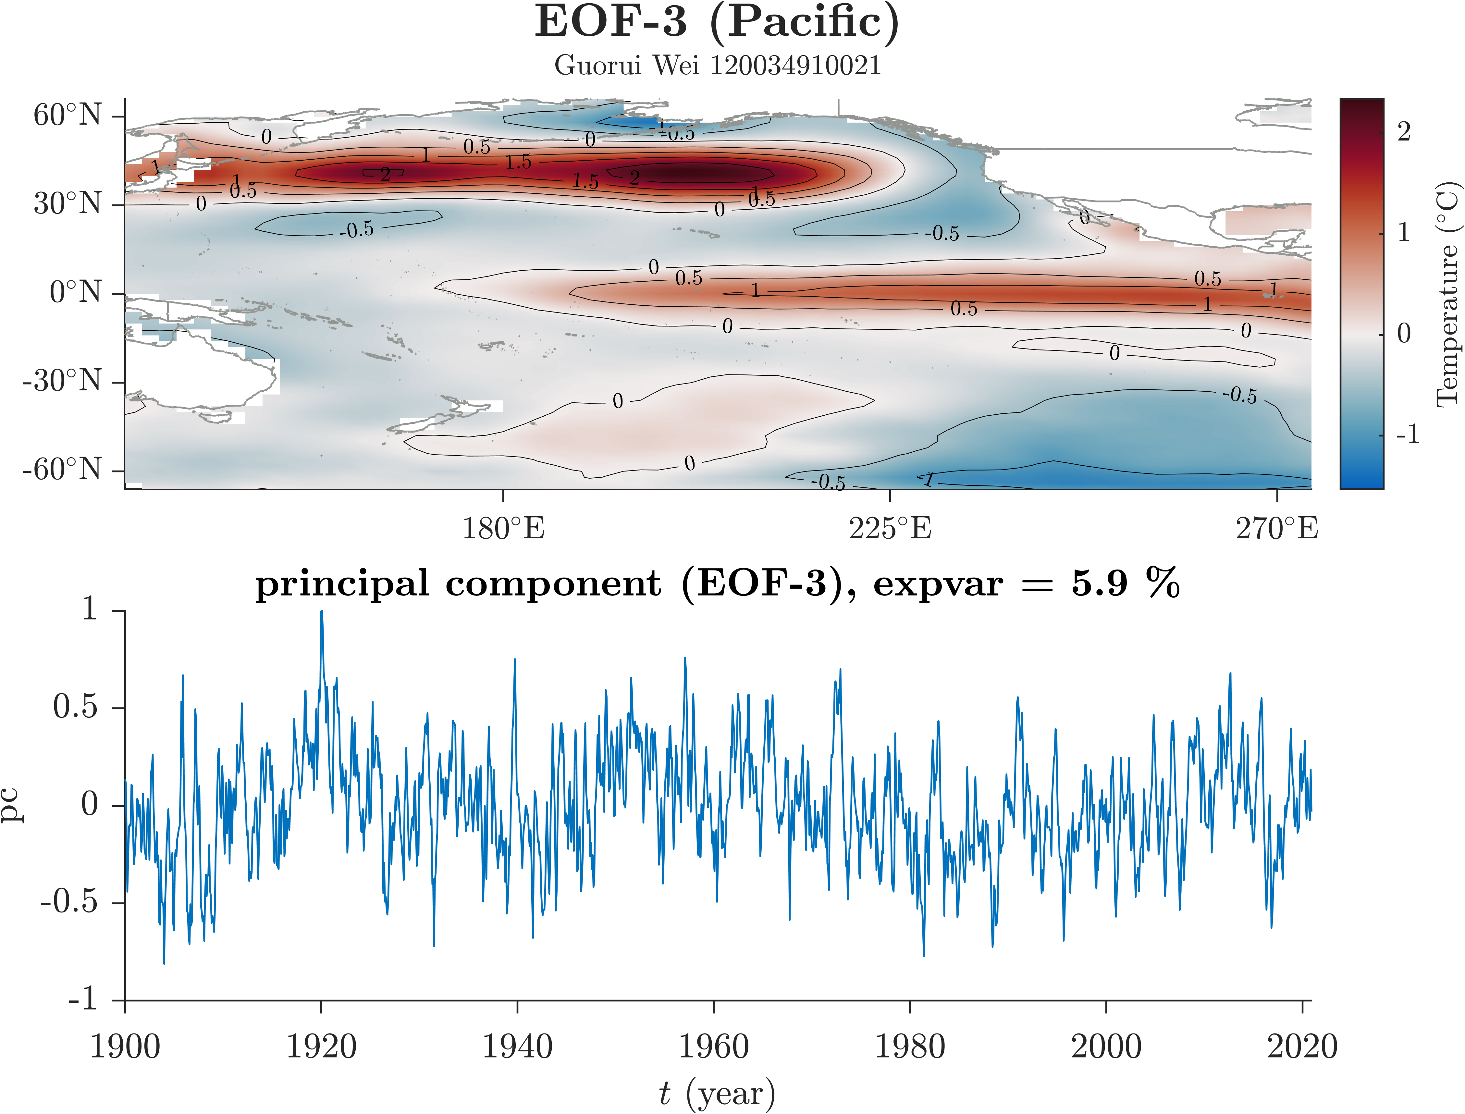

**Figure 2** 太平洋区域EOF的前3个mode，相应的principal component time series和percent of variance explained by each mode. (a) EOF-1, (b) EOF-2, (c) EOF-3.

## The North Pacific Ocean

北太平洋区域EOF. 第一模态是PDO，解释方差18%.

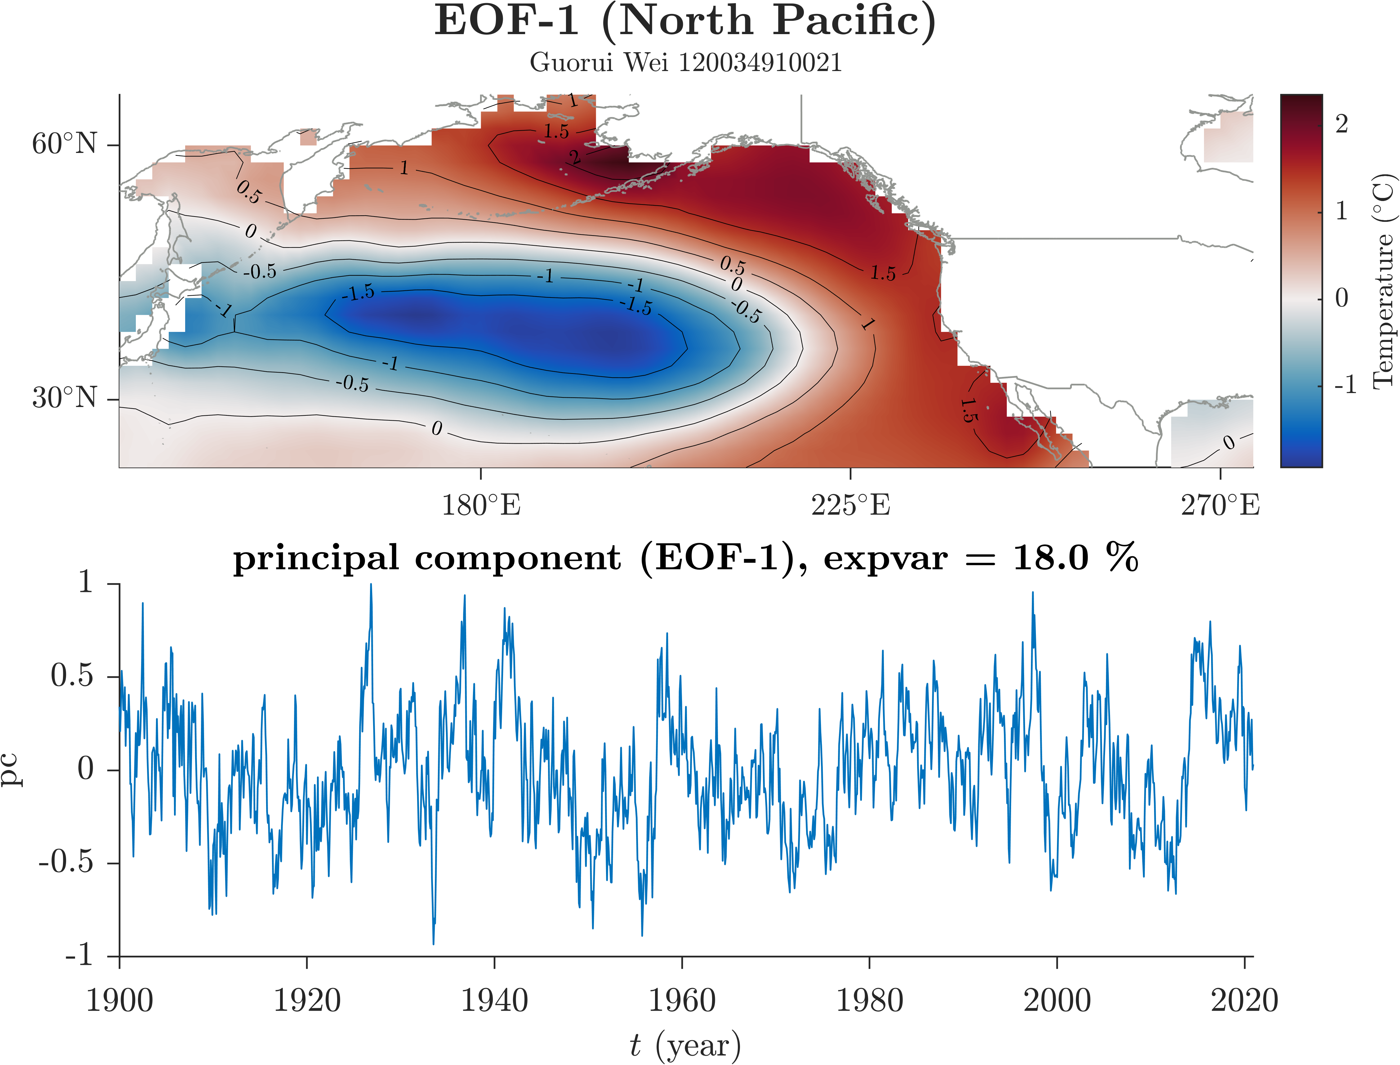

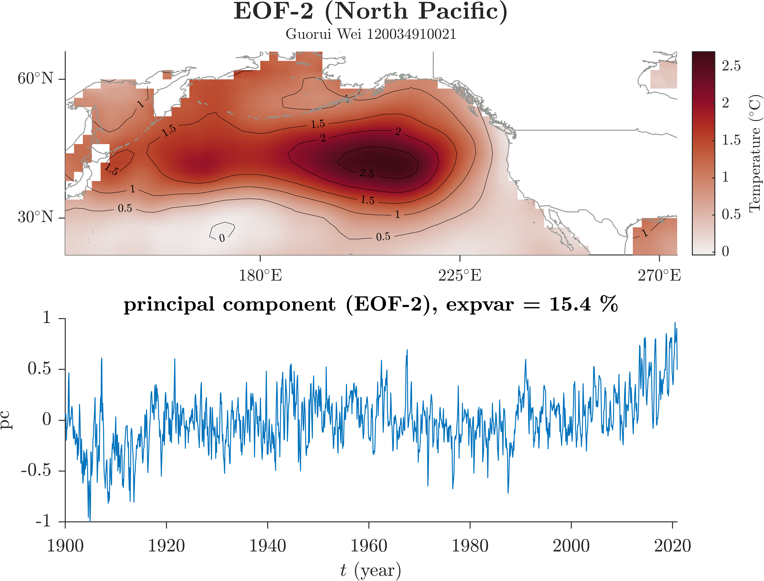

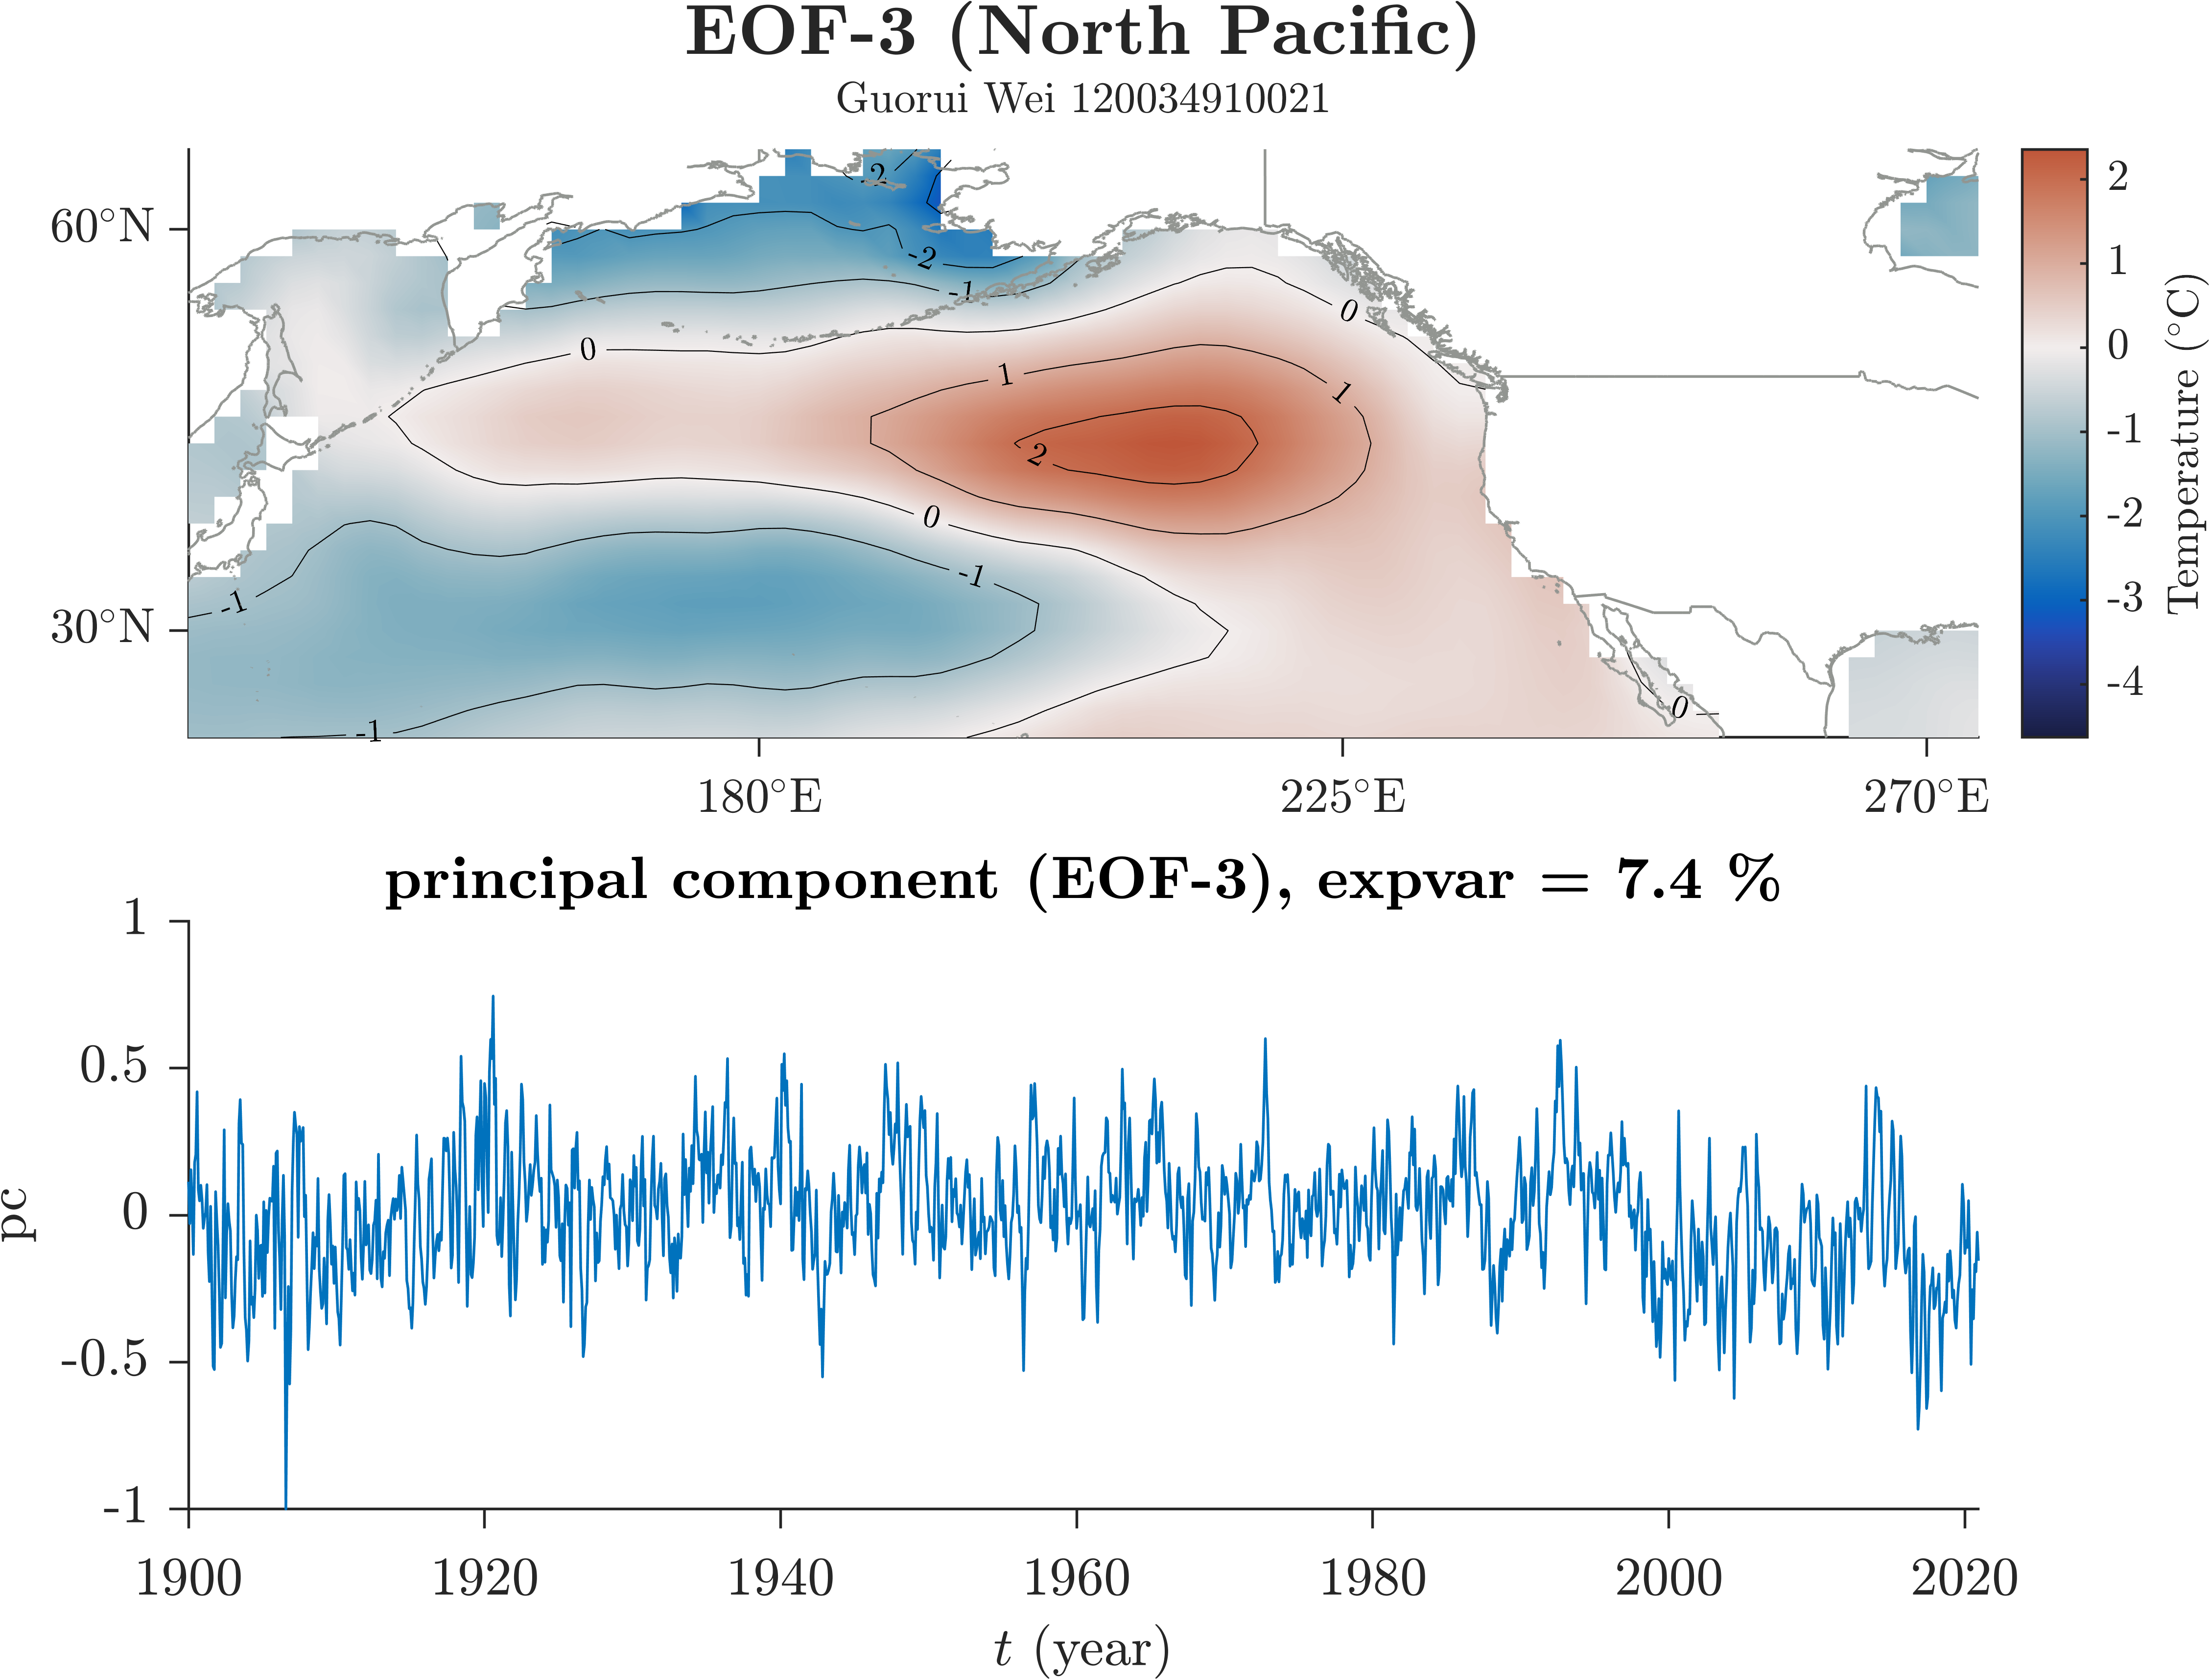

**Figure 3** 北太平洋区域EOF的前3个mode，相应的principal component time series和percent of variance explained by each mode. (a) EOF-1, (b) EOF-2, (c) EOF-3.

## The Atlantic Ocean

大西洋区域EOF. 第一模态，体现AMO，60-80年期的，解释方差>12%；第二模态？解释方差>11%；第三模态？

大西洋区域EOF前两个模态的解释方差之和>23%.

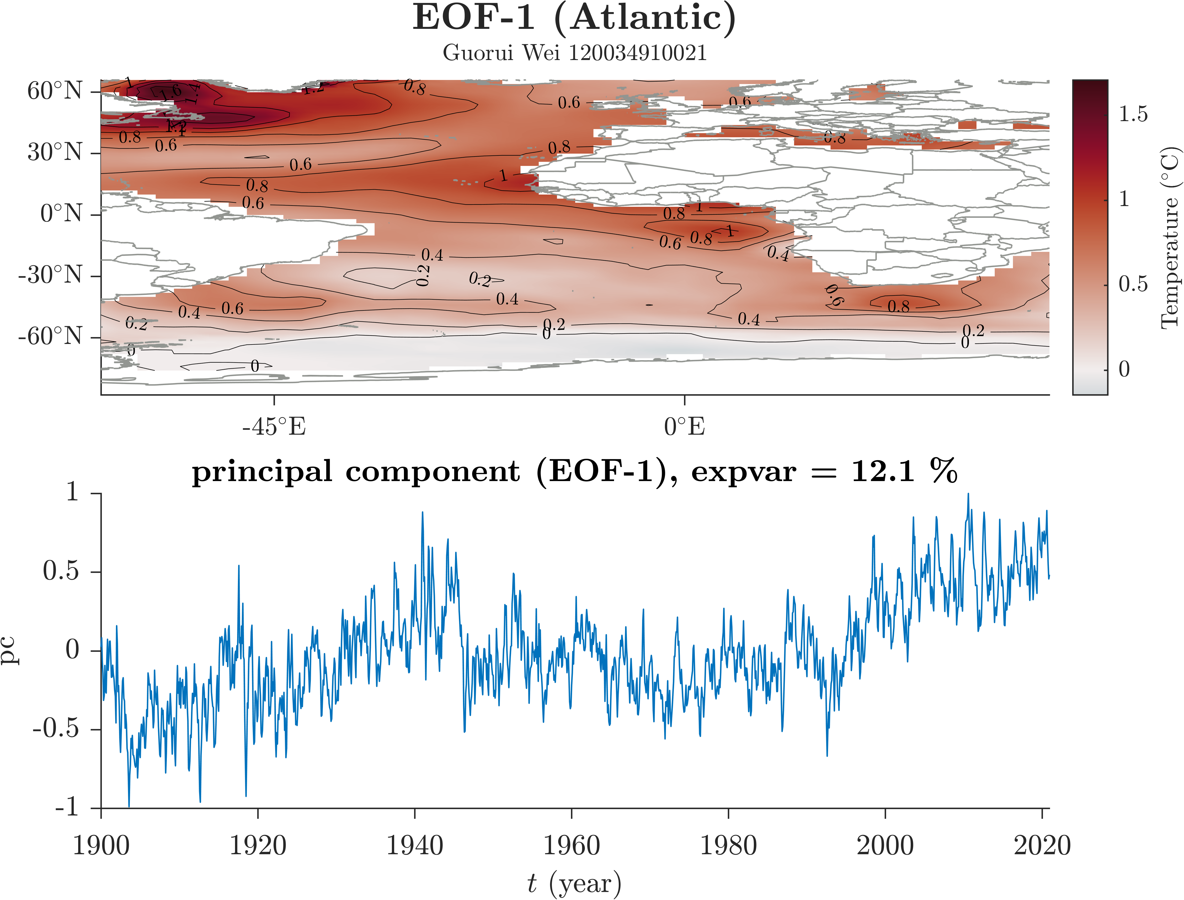

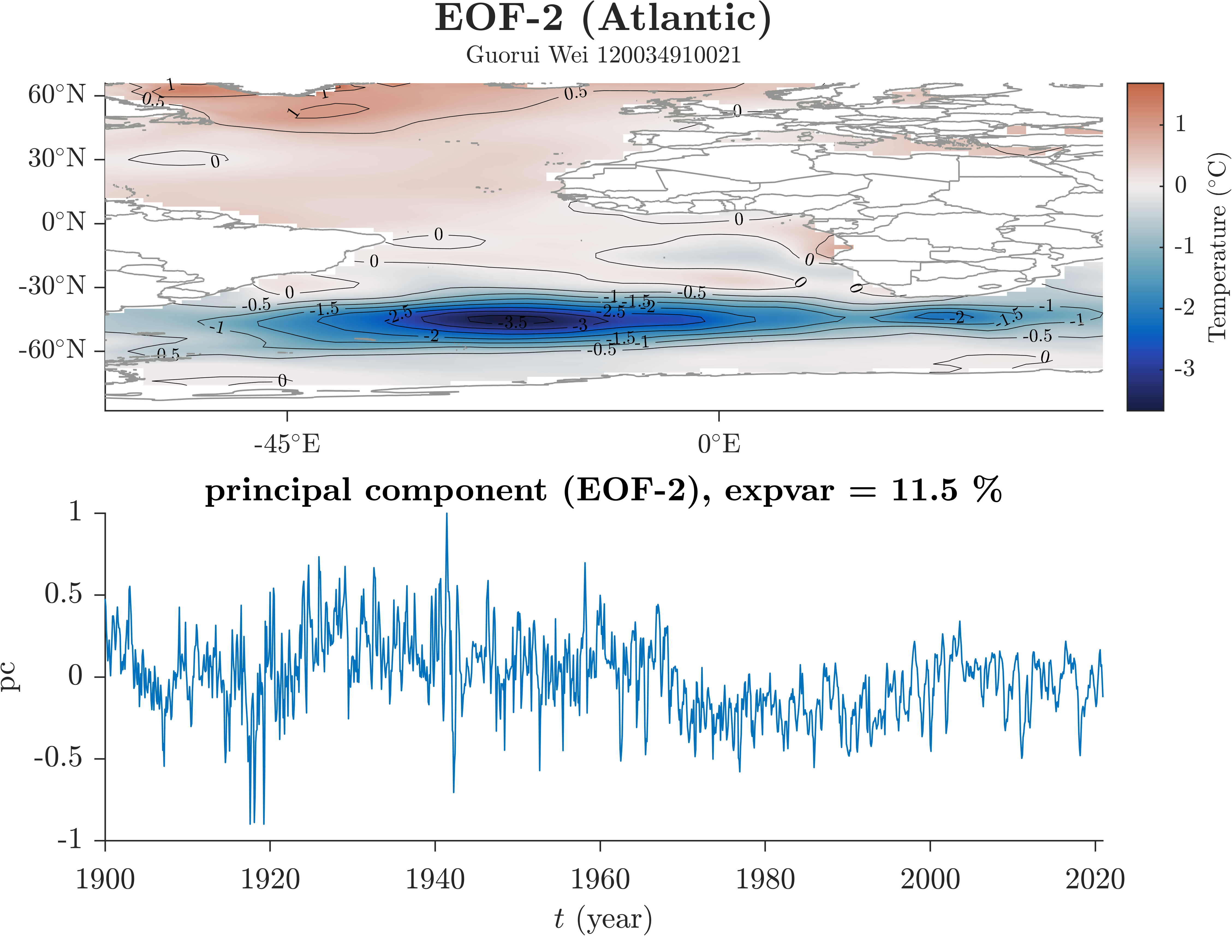

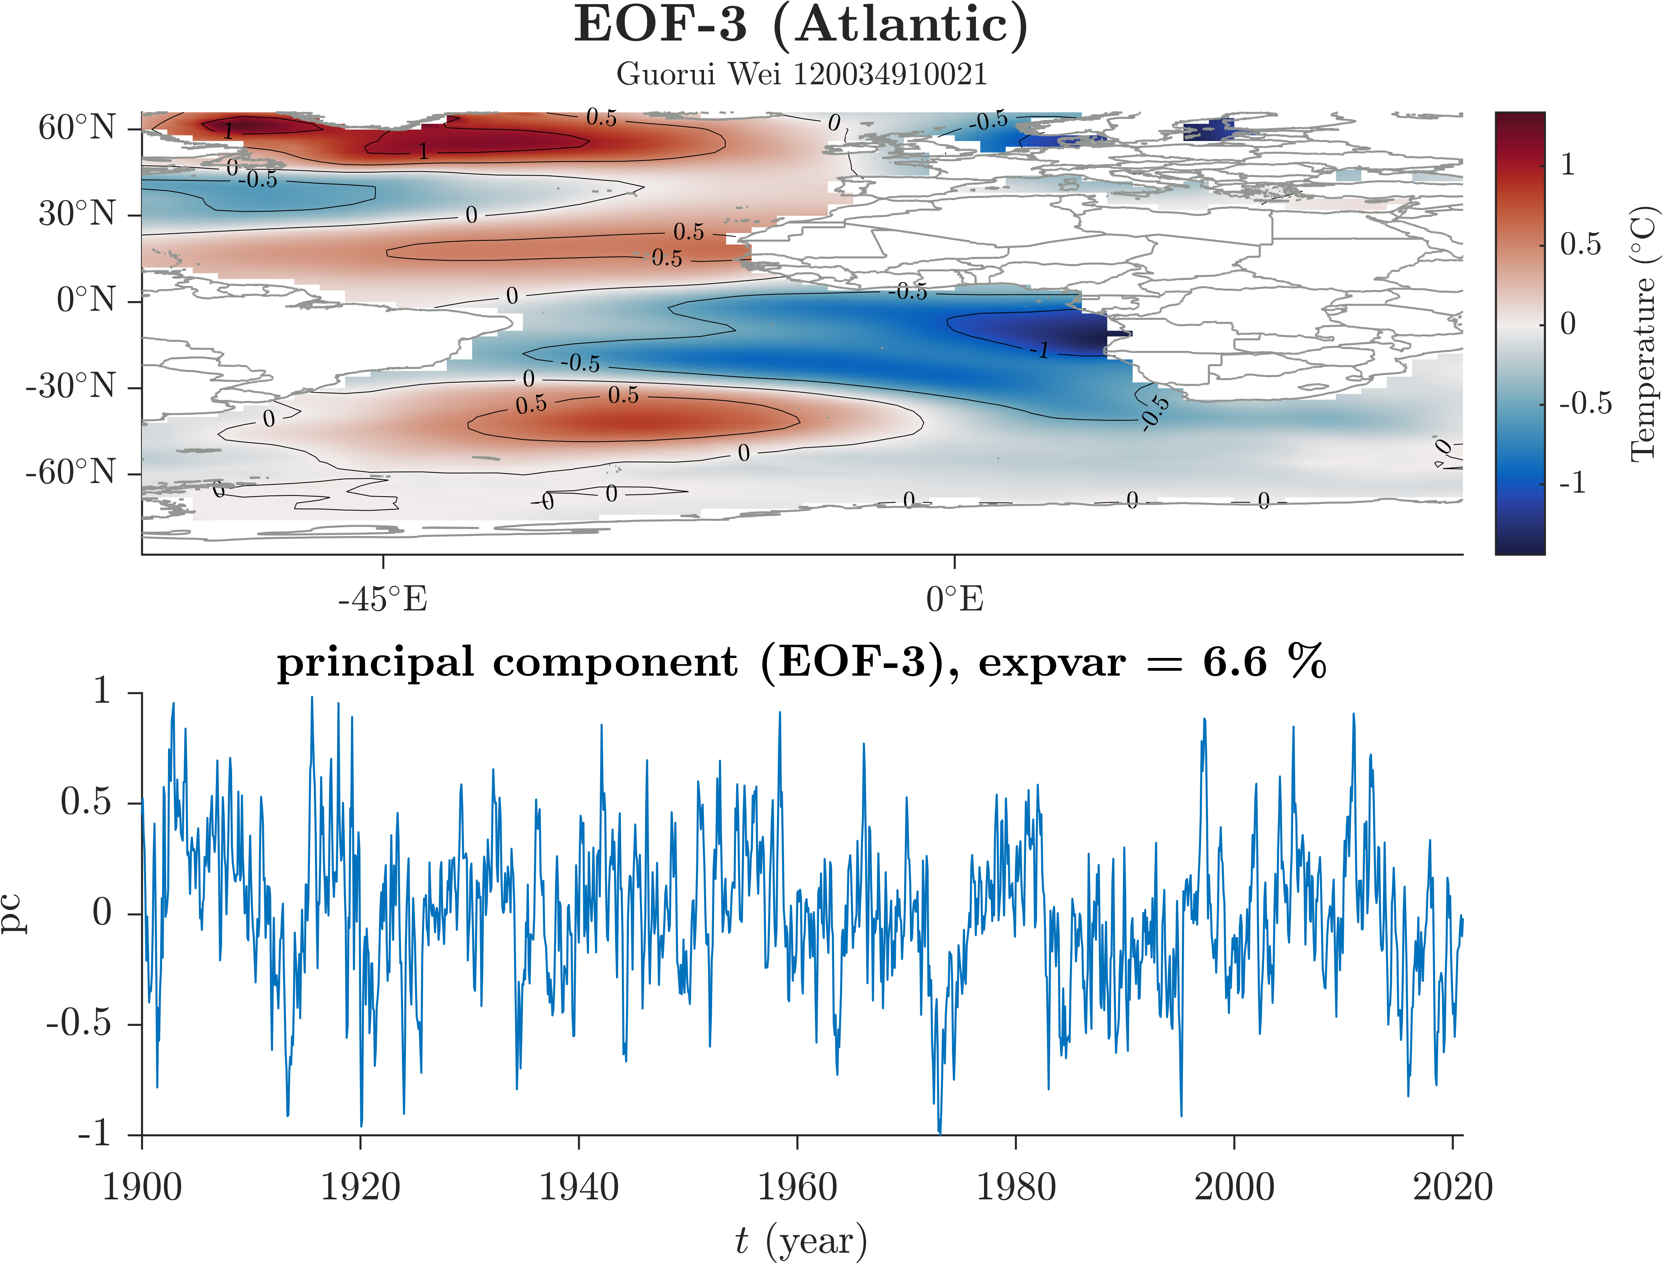

**Figure 4** 大西洋区域EOF的前3个mode，相应的principal component time series和percent of variance explained by each mode. (a) EOF-1, (b) EOF-2, (c) EOF-3.

## The North Atlantic Ocean

北大西洋区域EOF. 第一模态，体现AMO，解释方差超过24%；第二模态，？，解释方差超过12%；第三模态，？，解释方差接近10%.

与大西洋区域EOF相比，北大西洋区域EOF的第一模态的AMO特征更明显，解释方差更高. 北大西洋区域EOF的第二、三模态的解释方差较高，在大西洋区域EOF和全球EOF中体现不明显？

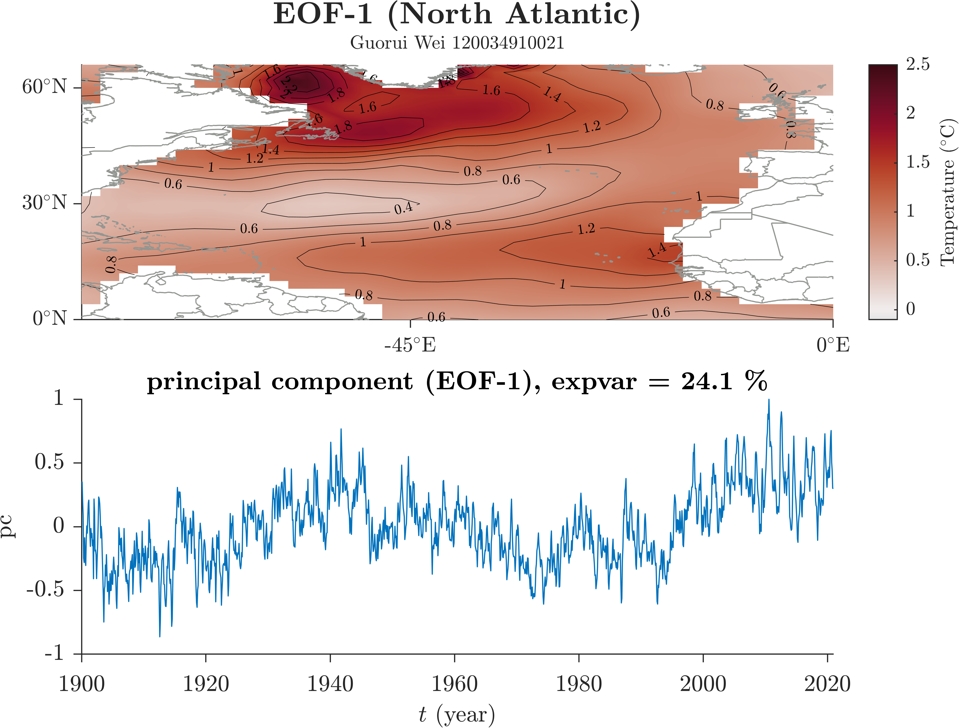

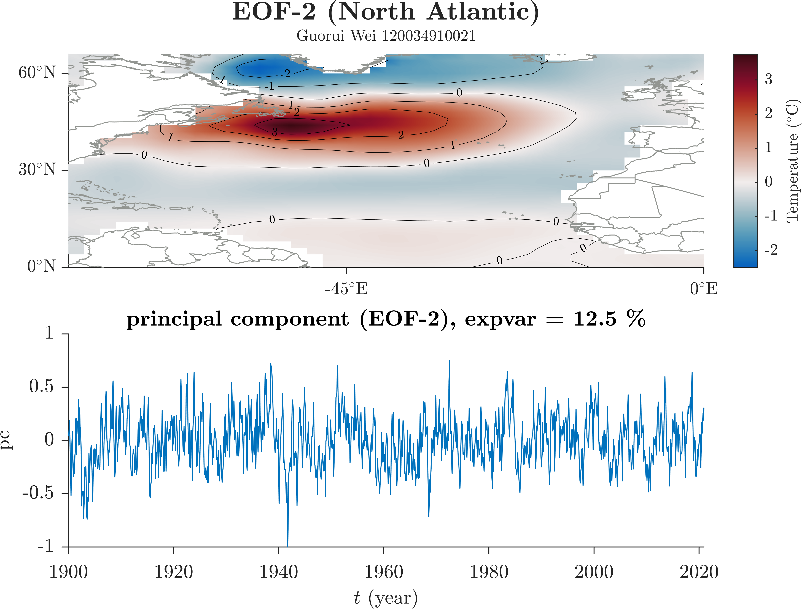

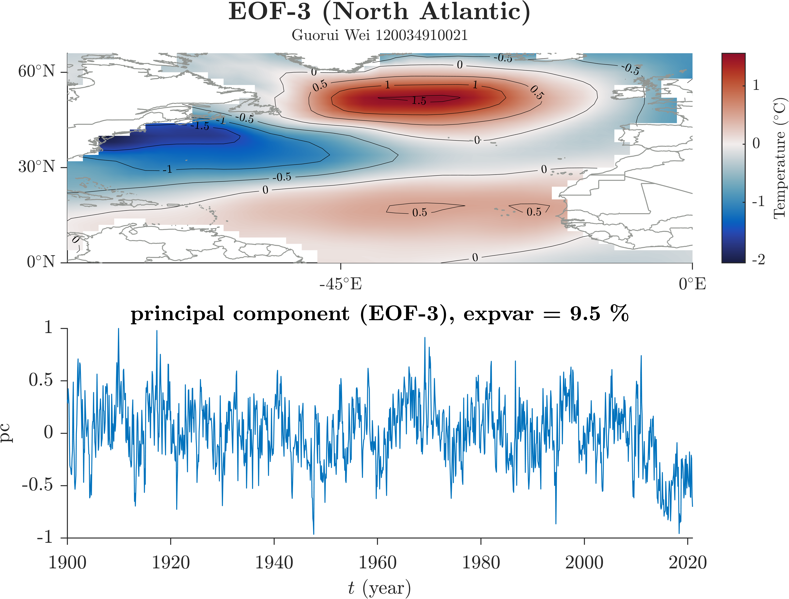

**Figure 5** 北大西洋区域EOF的前3个mode，相应的principal component time series和percent of variance explained by each mode. (a) EOF-1, (b) EOF-2, (c) EOF-3.

# Discussion

全球EOF的前两个模态能分别体现ENSO和PDO.

PDO在全球EOF的第二模态有体现，在太平洋区域EOF的第二模态更明显，在北太平洋区域EOF中成为第一模态.

AMO在全球EOF中不明显，在大西洋区域EOF成为第一模态，在北大西洋区域EOF中成为解释方差更高的第一模态.

# Conclusions

EOF分析的结果高度依赖于区域选取. 全球EOF的结果不是各区域分别EOF的结果的简单叠加. 在全球EOF中，局部重要的气候模态可能被“淹没”在众多模态中，而不能被EOF很好地分辨出.

References

[] Chad A. Greene, Kaustubh Thirumalai, Kelly A. Kearney, Jose Miguel Delgado, Wolfgang Schwanghart, Natalie S. Wolfenbarger, Kristen M. Thyng, David E. Gwyther, Alex S. Gardner, and Donald D. Blankenship (2019). The Climate Data Toolbox for MATLAB. *Geochemistry, Geophysics, Geosystems*, *20*, 3774-3781. doi:10.1029/2019GC008392

[] Zhihua Zhang, John C. Moore. [Mathematical and Physical Fundamentals of Climate Change](https://www.sciencedirect.com/book/9780128000663/mathematical-and-physical-fundamentals-of-climate-change), 2015. https://doi.org/10.1016/C2013-0-14403-0

1. 本文使用的MATLAB程序源代码

本文使用的程序和文档发布于<https://grwei.github.io/SJTU_2021-2022-2_MS8401/>.

* 1. 主程序

|  |  |
| --- | --- |
| 1 | %% hw2.m |
| 2 | % Description: MATLAB code for Homework 2 (MS8401, 2022 Spring) |
| 3 | % Author: Guorui Wei (危国锐) (313017602@qq.com; weiguorui@sjtu.edu.cn) |
| 4 | % Student ID: 120034910021 |
| 5 | % Created: 2022-05-12 |
| 6 | % Last modified: 2022-05-14 |
| 7 | % References: [1] [CDT::eof documentation](https://www.chadagreene.com/CDT/eof_documentation.html) |
| 8 | %             [2] [Pacific Decadal Oscillation (PDO)](https://psl.noaa.gov/pdo/) |
| 9 | %             [3] [AMO] Trenberth, Kevin, Zhang, Rong & National Center for Atmospheric Research Staff (Eds). Last modified 05 Jun 2021. "The Climate Data Guide: Atlantic Multi-decadal Oscillation (AMO)." Retrieved from https://climatedataguide.ucar.edu/climate-data/atlantic-multi-decadal-oscillation-amo. |
| 10 | %             [4] [PDO] Deser, Clara, Trenberth, Kevin & National Center for Atmospheric Research Staff (Eds). Last modified 06 Jan 2016. "The Climate Data Guide: Pacific Decadal Oscillation (PDO): Definition and Indices." Retrieved from https://climatedataguide.ucar.edu/climate-data/pacific-decadal-oscillation-pdo-definition-and-indices. |
| 11 | %             [5] [NAO] National Center for Atmospheric Research Staff (Eds). Last modified 17 Apr 2022. "The Climate Data Guide: Hurrell North Atlantic Oscillation (NAO) Index (PC-based)." Retrieved from https://climatedataguide.ucar.edu/climate-data/hurrell-north-atlantic-oscillation-nao-index-pc-based. |
| 12 | %             [6] [ENSO] [El Niño Southern Oscillation (ENSO)](https://psl.noaa.gov/enso/) |
| 13 | % Toolbox:    [T1] [M_Map: A mapping package for Matlab](https://www.eoas.ubc.ca/~rich/map.html) |
| 14 | %             [T2] [Climate Data Tools for Matlab](https://github.com/chadagreene/CDT) |
| 15 | % Data:       [D1] [NOAA Extended Reconstructed Sea Surface Temperature (SST) V5](https://psl.noaa.gov/data/gridded/data.noaa.ersst.v5.html) |
| 16 |  |
| 17 | %% Initialize project |
| 18 |  |
| 19 | clc; clear; close all |
| 20 | init_env(); |
| 21 |  |
| 22 | %% Read data |
| 23 |  |
| 24 | nc_path = "..\data\sst.mnmean.nc"; |
| 25 | nc_info = ncinfo(nc_path); |
| 26 | sst = double(ncread(nc_path,'sst')); % [deg C] sst(lon,lat,time_month) |
| 27 | sst(sst == ncreadatt(nc_path,'/sst','missing_value')) = NaN; % Monthly Means of Sea Surface Temperature (SST) |
| 28 | lon = double(ncread(nc_path,'lon')); % [deg E] |
| 29 | lat = double(ncread(nc_path,'lat')); % [deg N] |
| 30 | time_month = (datetime(1854,1,15) + calmonths(0:size(sst,3)-1)).'; |
| 31 |  |
| 32 | %% pre-processing |
| 33 |  |
| 34 | sst_dtr = detrend3(sst,'omitnan'); % Remove the global warming signal (detrended) |
| 35 | sst_var = deseason(sst_dtr,time_month); % Remove seasonal cycles (detrended and seasonal cycle removed -> variability) |
| 36 |  |
| 37 | %% 1. global |
| 38 |  |
| 39 | TF_lon_range = lon > -Inf & lon < +Inf; |
| 40 | TF_lat_range = lat > -Inf & lat < +Inf; |
| 41 | TF_time_range = datetime(1900,1,1) < time_month & time_month < datetime(2020,12,30); |
| 42 |  |
| 43 | %%% eof |
| 44 |  |
| 45 | n_eof = 3; % only calculates the first n modes of variability |
| 46 | [eof_maps,pc,expvar] = eof(sst_var(TF_lon_range,TF_lat_range,TF_time_range),n_eof); |
| 47 | % Optional scaling of Principal Components and EOF maps |
| 48 | for k = 1:size(pc,1) |
| 49 | % Find the the maximum value in the time series of each principal component: |
| 50 | maxval = max(abs(pc(k,:))); |
| 51 | % Divide the time series by its maximum value: |
| 52 | pc(k,:) = pc(k,:)/maxval; |
| 53 | % Multiply the corresponding EOF map: |
| 54 | eof_maps(:,:,k) = eof_maps(:,:,k)*maxval; |
| 55 | end |
| 56 |  |
| 57 | %%% Create figure. |
| 58 | for num_EOF = 1:3 |
| 59 | EOF_fig(num_EOF,"Global",lon(TF_lon_range),lat(TF_lat_range),time_month(TF_time_range),eof_maps,pc,expvar,1) |
| 60 | end |
| 61 |  |
| 62 | %% 2. the Pacific Ocean (85°33'S ~ 65°44'N, 99°10'E -> 180°+78°08'E) |
| 63 |  |
| 64 | TF_lon_range = lon > 134 & lon < 276; |
| 65 | TF_lat_range = lat > -67 & lat < 67; |
| 66 | TF_time_range = datetime(1900,1,1) < time_month & time_month < datetime(2020,12,30); |
| 67 |  |
| 68 | %%% eof |
| 69 |  |
| 70 | n_eof = 3; % only calculates the first n modes of variability |
| 71 | [eof_maps,pc,expvar] = eof(sst_var(TF_lon_range,TF_lat_range,TF_time_range),n_eof); |
| 72 | % Optional scaling of Principal Components and EOF maps |
| 73 | for k = 1:size(pc,1) |
| 74 | % Find the the maximum value in the time series of each principal component: |
| 75 | maxval = max(abs(pc(k,:))); |
| 76 | % Divide the time series by its maximum value: |
| 77 | pc(k,:) = pc(k,:)/maxval; |
| 78 | % Multiply the corresponding EOF map: |
| 79 | eof_maps(:,:,k) = eof_maps(:,:,k)*maxval; |
| 80 | end |
| 81 |  |
| 82 | %%% Create figure. |
| 83 | for num_EOF = 1:3 |
| 84 | EOF_fig(num_EOF,"Pacific",lon(TF_lon_range),lat(TF_lat_range),time_month(TF_time_range),eof_maps,pc,expvar,1) |
| 85 | end |
| 86 |  |
| 87 | %% 3. the Atlantic Ocean |
| 88 |  |
| 89 | %%% prepare |
| 90 |  |
| 91 | % convert longitute from 0~360 deg E to -180~180 deg E |
| 92 | n_lon_W = sum(lon >= 180); |
| 93 | lon_0 = circshift(lon,n_lon_W); |
| 94 | lon_0(lon_0 >= 180) = lon_0(lon_0 >= 180) - 360; |
| 95 | sst_var_0 = circshift(sst_var,n_lon_W,1); |
| 96 | % |
| 97 | TF_lon_range = (lon_0 > -65 & lon_0 < 41); |
| 98 | TF_lat_range = lat > -101 & lat < 67; |
| 99 | TF_time_range = datetime(1900,1,1) < time_month & time_month < datetime(2020,12,30); |
| 100 |  |
| 101 | %%% eof |
| 102 |  |
| 103 | n_eof = 3; % only calculates the first n modes of variability |
| 104 | [eof_maps,pc,expvar] = eof(sst_var_0(TF_lon_range,TF_lat_range,TF_time_range),n_eof); |
| 105 | % Optional scaling of Principal Components and EOF maps |
| 106 | for k = 1:size(pc,1) |
| 107 | % Find the the maximum value in the time series of each principal component: |
| 108 | maxval = max(abs(pc(k,:))); |
| 109 | % Divide the time series by its maximum value: |
| 110 | pc(k,:) = pc(k,:)/maxval; |
| 111 | % Multiply the corresponding EOF map: |
| 112 | eof_maps(:,:,k) = eof_maps(:,:,k)*maxval; |
| 113 | end |
| 114 |  |
| 115 | %%% Create figure. |
| 116 | for num_EOF = 1:3 |
| 117 | EOF_fig(num_EOF,"Atlantic",lon_0(TF_lon_range),lat(TF_lat_range),time_month(TF_time_range),eof_maps,pc,expvar,1) |
| 118 | end |
| 119 |  |
| 120 | %% 4. the North Atlantic Ocean |
| 121 |  |
| 122 | %%% prepare |
| 123 |  |
| 124 | % convert longitute from 0~360 deg E to -180~180 deg E |
| 125 | n_lon_W = sum(lon >= 180); |
| 126 | lon_0 = circshift(lon,n_lon_W); |
| 127 | lon_0(lon_0 >= 180) = lon_0(lon_0 >= 180) - 360; |
| 128 | sst_var_0 = circshift(sst_var,n_lon_W,1); |
| 129 | % |
| 130 | TF_lon_range = (lon_0 > -81 & lon_0 < 1); |
| 131 | TF_lat_range = lat > -1 & lat < 67; |
| 132 | TF_time_range = datetime(1900,1,1) < time_month & time_month < datetime(2020,12,30); |
| 133 |  |
| 134 | %%% eof |
| 135 |  |
| 136 | n_eof = 3; % only calculates the first n modes of variability |
| 137 | [eof_maps,pc,expvar] = eof(sst_var_0(TF_lon_range,TF_lat_range,TF_time_range),n_eof); |
| 138 | % Optional scaling of Principal Components and EOF maps |
| 139 | for k = 1:size(pc,1) |
| 140 | % Find the the maximum value in the time series of each principal component: |
| 141 | maxval = max(abs(pc(k,:))); |
| 142 | % Divide the time series by its maximum value: |
| 143 | pc(k,:) = pc(k,:)/maxval; |
| 144 | % Multiply the corresponding EOF map: |
| 145 | eof_maps(:,:,k) = eof_maps(:,:,k)*maxval; |
| 146 | end |
| 147 |  |
| 148 | %%% Create figure. |
| 149 | for num_EOF = 1:3 |
| 150 | EOF_fig(num_EOF,"North Atlantic",lon_0(TF_lon_range),lat(TF_lat_range),time_month(TF_time_range),eof_maps,pc,expvar,1) |
| 151 | end |
| 152 |  |
| 153 | %% 5. the North Pacific Ocean (20°N ~ 65°44'N, 99°10'E -> 180°+78°08'E) |
| 154 |  |
| 155 | TF_lon_range = lon > 134 & lon < 276; |
| 156 | TF_lat_range = lat > 20 & lat < 67; |
| 157 | TF_time_range = datetime(1900,1,1) < time_month & time_month < datetime(2020,12,30); |
| 158 |  |
| 159 | %%% eof |
| 160 |  |
| 161 | n_eof = 3; % only calculates the first n modes of variability |
| 162 | [eof_maps,pc,expvar] = eof(sst_var(TF_lon_range,TF_lat_range,TF_time_range),n_eof); |
| 163 | % Optional scaling of Principal Components and EOF maps |
| 164 | for k = 1:size(pc,1) |
| 165 | % Find the the maximum value in the time series of each principal component: |
| 166 | maxval = max(abs(pc(k,:))); |
| 167 | % Divide the time series by its maximum value: |
| 168 | pc(k,:) = pc(k,:)/maxval; |
| 169 | % Multiply the corresponding EOF map: |
| 170 | eof_maps(:,:,k) = eof_maps(:,:,k)*maxval; |
| 171 | end |
| 172 |  |
| 173 | %%% Create figure. |
| 174 | for num_EOF = 1:3 |
| 175 | EOF_fig(num_EOF,"North Pacific",lon(TF_lon_range),lat(TF_lat_range),time_month(TF_time_range),eof_maps,pc,expvar,1) |
| 176 | end |
| 177 |  |
| 178 | %% local functions |
| 179 |  |
| 180 | %% Initialize environment |
| 181 |  |
| 182 | function [] = init_env() |
| 183 | % Initialize environment |
| 184 | % |
| 185 | % set up project directory |
| 186 | if ~isfolder("../doc/fig/hw2") |
| 187 | mkdir ../doc/fig/hw2 |
| 188 | end |
| 189 | % configure searching path |
| 190 | mfile_fullpath = mfilename('fullpath'); % the full path and name of the file in which the call occurs, not including the filename extension. |
| 191 | mfile_fullpath_without_fname = mfile_fullpath(1:end-strlength(mfilename)); |
| 192 | addpath(genpath(mfile_fullpath_without_fname + "../data"), ... |
| 193 | genpath(mfile_fullpath_without_fname + "../inc")); % adds the specified folders to the top of the search path for the current MATLAB® session. |
| 194 |  |
| 195 | return; |
| 196 | end |
| 197 |  |
| 198 | %% Create EOF figure. |
| 199 |  |
| 200 | function [] = EOF_fig(num_EOF,title_str,lon,lat,time_month,eof_maps,pc,expvar,TF_export) |
| 201 | arguments |
| 202 | num_EOF |
| 203 | title_str |
| 204 | lon |
| 205 | lat |
| 206 | time_month |
| 207 | eof_maps |
| 208 | pc |
| 209 | expvar |
| 210 | TF_export |
| 211 | end |
| 212 |  |
| 213 | figure('Name',sprintf("EOF-%d (%s)",num_EOF,title_str)) |
| 214 | t_TCL = tiledlayout(2,1,"TileSpacing","tight","Padding","tight"); |
| 215 |  |
| 216 | %%% EOF |
| 217 |  |
| 218 | t_axes = nexttile(t_TCL,1); |
| 219 | pcolor(t_axes,lon,lat,eof_maps(:,:,num_EOF).'); |
| 220 | shading(t_axes,"interp"); |
| 221 | hold on |
| 222 | [C,h] = contour(t_axes,lon,lat,eof_maps(:,:,num_EOF).','LineWidth',0.2,'LineColor','black','ShowText','off'); |
| 223 | borders('countries','center',180,'color',rgb('gray')) |
| 224 | hold off |
| 225 | clabel(C,h,"Interpreter",'latex','FontSize',6) |
| 226 | % BEGIN patch |
| 227 | cl = caxis; |
| 228 | if (cl(1) >= 0) |
| 229 | cl(1) = -0.1; |
| 230 | caxis(t_axes,cl) |
| 231 | end |
| 232 | % END patch |
| 233 | colormap(t_axes,cmocean('balance','pivot',0)) |
| 234 | cb = colorbar(t_axes,"eastoutside","TickLabelInterpreter","latex"); |
| 235 | set(cb.Label,"String","Temperature ($^{\circ}\rm{C}$)","Interpreter","latex") |
| 236 | set(t_axes,"TickLabelInterpreter","latex","TickDir","out",'YDir','normal','Box','off'); |
| 237 | xticks(t_axes,-180:45:360) |
| 238 | xtickformat(t_axes,'%g$^{\\circ}\\rm{E}$') |
| 239 | yticks(-90:30:90) |
| 240 | ytickformat(t_axes,'%g$^{\\circ}\\rm{N}$') |
| 241 | % xlabel(t_axes,"longitude (deg E)",'Interpreter','latex') |
| 242 | % ylabel(t_axes,"latitude (deg N)",'Interpreter','latex') |
| 243 | % |
| 244 | [~,t_title_s] = title(t_TCL,sprintf("\\bf EOF-%d (%s)",num_EOF,title_str),"Guorui Wei 120034910021",'Interpreter','latex'); |
| 245 | set(t_title_s,'FontSize',8); |
| 246 |  |
| 247 | %%% pc |
| 248 |  |
| 249 | t_axes = nexttile(t_TCL,2); |
| 250 | plot(t_axes,time_month,pc(num_EOF,:),'-',"DisplayName",'pc'); |
| 251 | set(t_axes,"YDir",'normal',"TickLabelInterpreter",'latex',"FontSize",10,'Box','off','TickDir','out','XLimitMethod','tight'); |
| 252 | % legend(t_axes,"Location",'best','Interpreter','latex',"Box","off",'FontSize',10); |
| 253 | xticks(t_axes,datetime(1900,1,15) + calyears(0:20:120)) |
| 254 | xtickformat(t_axes,'yyyy') |
| 255 | xlabel(t_axes,"$t$ (year)",FontSize=10,Interpreter="latex"); |
| 256 | ylabel(t_axes,"pc","FontSize",10,"Interpreter","latex"); |
| 257 | title(t_axes,sprintf("\\bf principal component (EOF-%d), expvar = %.1f \\%%",num_EOF,expvar(num_EOF)),"Interpreter","latex"); |
| 258 |  |
| 259 | %%% export |
| 260 |  |
| 261 | if (TF_export) |
| 262 | exportgraphics(t_TCL,sprintf("..\\doc\\fig\\hw2\\hw2_EOF-%d_%s.emf",num_EOF,title_str),'Resolution',800,'ContentType','auto','BackgroundColor','none','Colorspace','rgb') |
| 263 | exportgraphics(t_TCL,sprintf("..\\doc\\fig\\hw2\\hw2_EOF-%d_%s.png",num_EOF,title_str),'Resolution',800,'ContentType','auto','BackgroundColor','none','Colorspace','rgb') |
| 264 | end |
| 265 |  |
| 266 | return; |
| 267 | end |
| 268 |  |

* 1. 子程序

本文使用的程序和文档发布于<https://grwei.github.io/SJTU_2021-2022-2_MS8401/>.

1. https://doi.org/10.1007/978-90-481-3702-2
2. https://doi.org/10.1016/B978-0-12-387782-6.00004-1
3. https://psl.noaa.gov/enso/
4. https://climatedataguide.ucar.edu/climate-data/pacific-decadal-oscillation-pdo-definition-and-indices
5. https://climatedataguide.ucar.edu/climate-data/atlantic-multi-decadal-oscillation-amo
6. https://climatedataguide.ucar.edu/climate-data/hurrell-north-atlantic-oscillation-nao-index-pc-based
7. https://psl.noaa.gov/data/gridded/data.noaa.ersst.v5.html
8. https://www.chadagreene.com/CDT/detrend3_documentation.html
9. https://www.chadagreene.com/CDT/deseason_documentation.html
10. https://www.chadagreene.com/CDT/eof_documentation.html